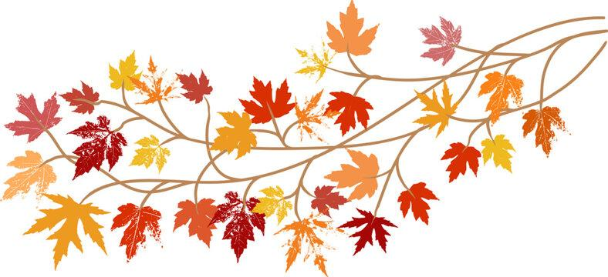
Year One Autumn Term Curriculum Overview
PE– Multi Skills and Throwing & Catching -
They will learn how to move in a variety of ways using different parts of their body. They will also focus on spatial awareness so they understand the importance of moving safely in a space. They will also learn how to balance on different parts of their body.

Mathematics– We will be covering a variety of topics involving number, shape and space, data handling, measures, and problem solving. It would be a great help over the next few weeks if you could practise number bonds to 10, doubles & halves and practise counting in 2s, 5s and 10s with your child.
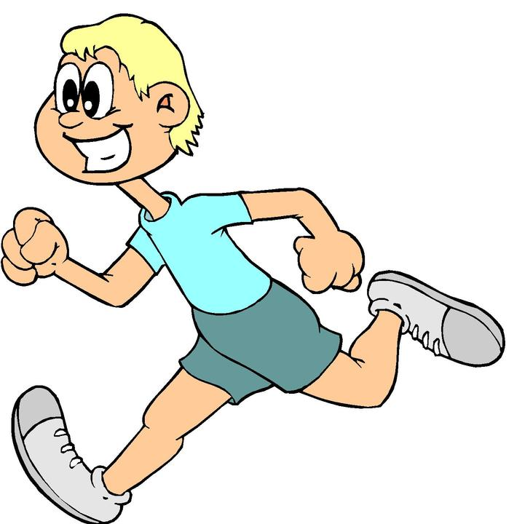
English–In the Autumn Term, we will develop our speaking and listening skills by talking about stories in familiar settings. Children will also create alphabetically ordered lists of different items as part of information texts. Focus on reading poems aloud and create their own repetitive poems.

Science– Animals Including Humans- learn about the different animal groups such as mammals, amphibians and reptiles. Understand the different parts of the human body and be able to label them.
Seasonal changes autumn to winter – build an understanding of the weather changes which take place.

ICT– Online Safety - We will focus on how to stay safe whilst using electrical devices and discuss the importance of being with a parent/carer when being online. Children will understand the importance of not speaking to strangers online and not disclosing personal information.

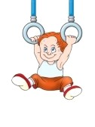
Geography– Children will be learning about the local area. They will get the opportunity to walk around the school and identify different locations.
R.E – Children will learn about the festival of Diwali and how it is celebrated in India and other parts of the world. Children will also learn to recognise that light is used as a religious symbol.
symbol and will learn how people from
different faiths celebrate.
Art & Design– Colour Chaos
In colour chaos, children will be learning about choosing, using, and mixing their own colours to create quality art work. We will also explore the work of abstract artists and learning about their specific works of art and discussing various techniques used.

PSHE- Health and well being – Aiming High
Health and well being – It’s my Body
Children will develop their social skills through circle time activities and games involving skills such as sharing and turn taking.

