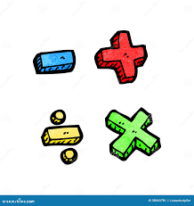

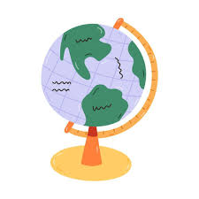
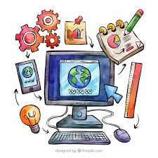
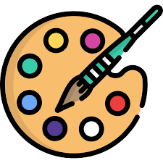
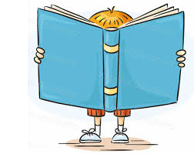
YEAR ONE SPRING TERM CURRICULUM OVERVIEW
PSHE- Children will learn about money, including where it comes from and how it is used. They will explore making choices about saving and spending, understand the difference between wants and needs, and develop confidence through discussion and role-play activities.

Art & Design– Exploring Colour
In this unit, children will learn to use and mix colours in different ways to create artwork. They will explore the work of abstract artists and discuss their styles and techniques, using these as inspiration for their own creative pieces.

PE– Multi Skills and Running & Jumping -
They will learn how to run and jump in a variety of ways, developing speed, control and coordination. Children will practise balancing, changing direction and using different body movements while moving. They will also focus on spatial awareness, helping them to move safely and confidently in a shared space.
Mathematics– We will be covering a range of topics including number, patterns, addition and subtraction, multiplication, measures and shape. Children will learn to compare numbers using mathematical language, recognise odd and even numbers, and solve simple problems involving addition, subtraction and multiplication. They will also explore counting in 2s and 5s, weighing objects, and recognising 2-D and 3-D shapes. It would be a great help if you could support your child at home by practising counting in 2s and 5s, number bonds within 20, and simple addition and subtraction.
English– In the Spring Term, we will develop children’s reading and writing skills through a range of engaging texts. Children will explore recounts by talking about familiar routines and writing their own simple recounts using time connectives. They will listen to, retell and role-play well-known stories, focusing on beginning, middle and end, before writing parts of a story independently. Children will also read, perform and create poems, developing an understanding of rhythm and rhyme through counting rhymes and repeated language.
Science– Everyday Materials – learn to identify and name different everyday materials such as wood, plastic, glass and metal. Explore the properties of materials, test which materials are suitable for different purposes, and sort materials based on their properties.

ICT– We will focus on developing children’s basic computer skills. Children will learn how to use a computer confidently, type and edit text, save their work, and create pictures using digital tools.
Geography– Children will be learning about the United Kingdom. They will explore different places, including towns and cities, and learn how places can be similar or different.
History – Children will learn about the history of travel and transport and how this has evolved over the years.

