YEAR TWO AUTUMN CURRICULUM OVERVIEW
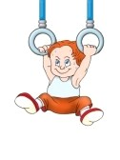
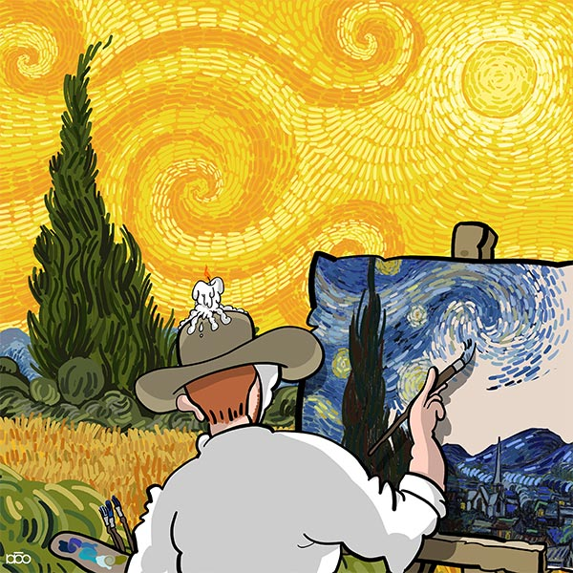
HUMANITIES – Children will be using their comparative skills to identify and discuss oceans and continents. They will also be learning about The Great Fire of London where they will also be able to learn how to compare and contrast present day London to the past by focussing on how life differed in the 17th century.


PE – In P.E. this term, the children will focus on Gymnastics. Children develop body tension, control and balance. Moving with greater agility and co-ordination. Children learn to link actions to copy and create movement sequences, which they perform to each other, evaluate and improve. This unit is linked to the Art unit and encourages children to think about how to stay healthy and how their bodies feel before and after exercise. This will also link to their Science topic when discussing health in Animals including Humans.

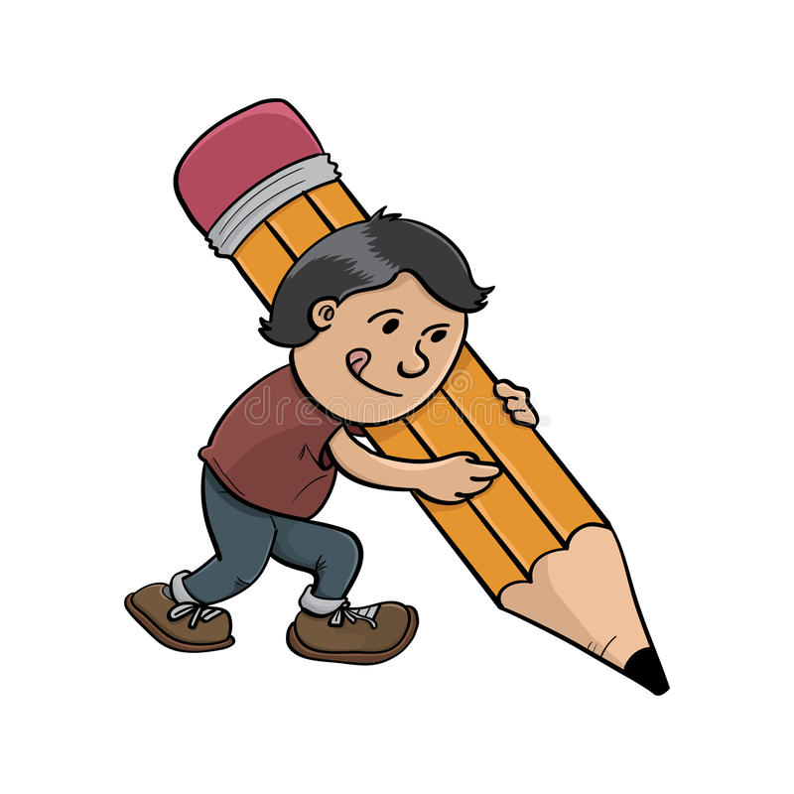
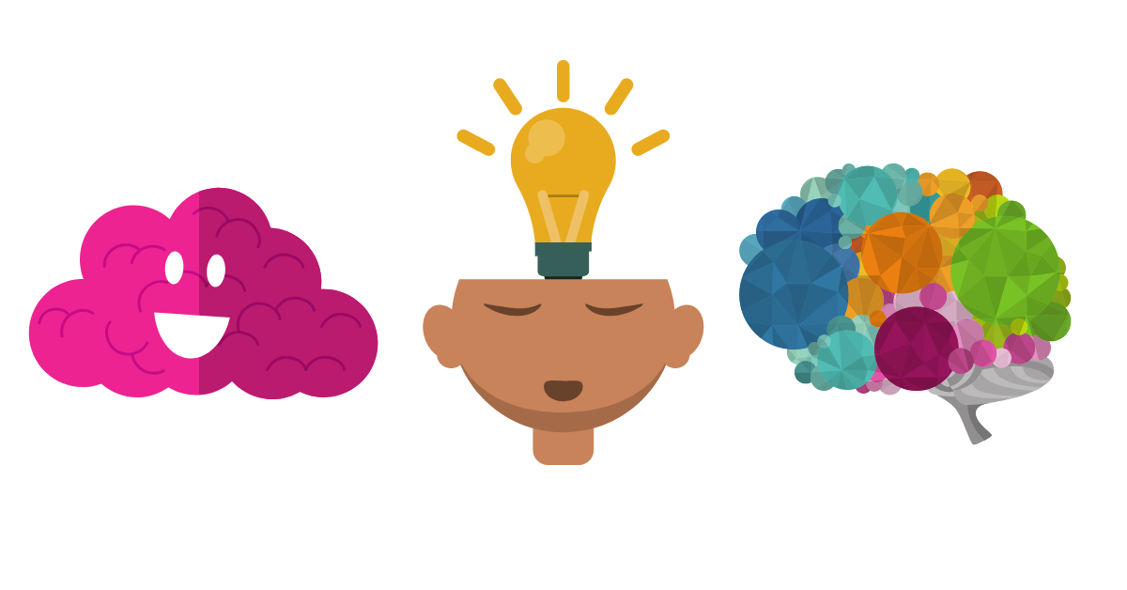
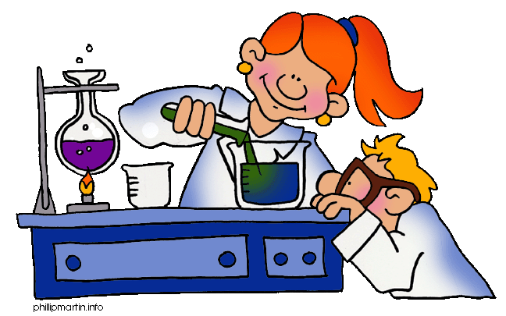
PSHE- This term we will focus on how children can keep safe whether at home, school, outside or on the worldwide web. This unit will also tie into their Computing Unit this term. Children will also develop their social skills through discussions and work on safety and how to take care of our mental health with an Islamic perspective. We will focus on thinking positively and counting our numerous blessings. We will also focus on how to deal with emotions such as anger, grief and disappointment.

ART & DESIGN – In our Cityscapes and Landscapes unit we will focus on 3 main artists (Monet, Gogh and Metzinger) where children will learn a variety of techniques.
In Design we will be looking at the different components needed to help us sew fabric faces.

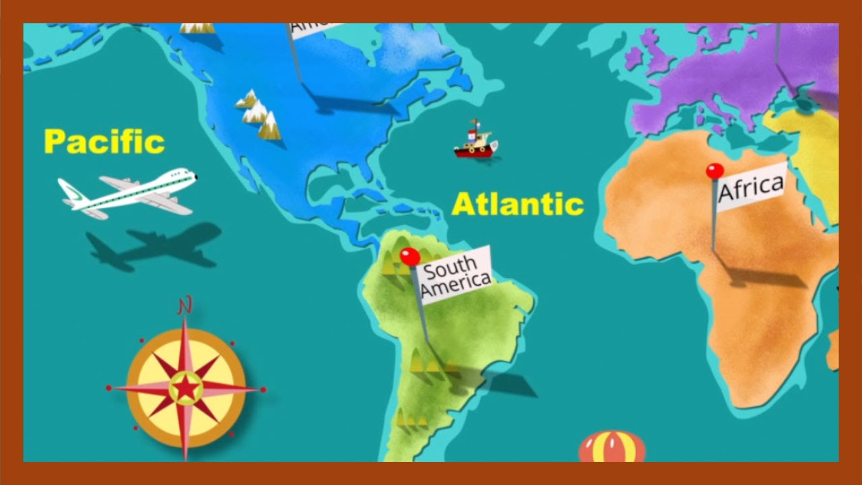
LITERACY – In the Autumn Term, we will develop our writing skills by exploring stories by Francesca Simon with familiar settings, poetry and non-fiction texts. We are going to focus on developing the following skills this term, so please support your child to practice these at home: correctly punctuating all sentences with a capital letter and full stop, using connectives such as and & because to link ideas in writing and practicing sentences out loud and re-reading them to check that they make sense. Please also help children to write their letters clearly and on the line.

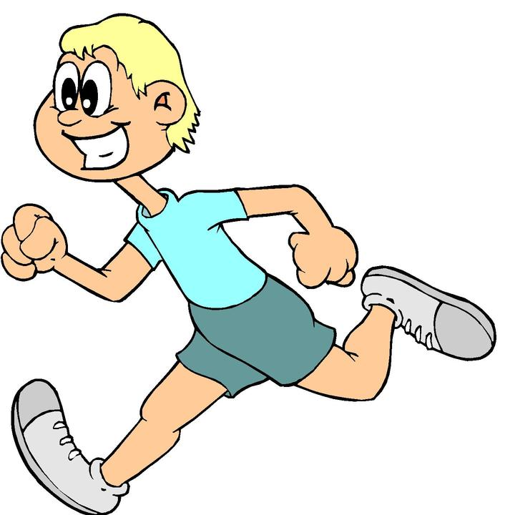
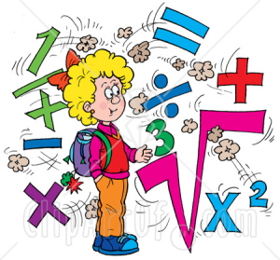
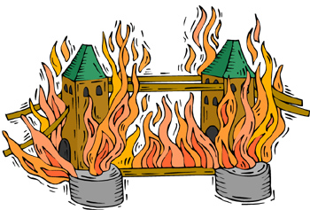
SCIENCE – This half term in Science, we will learn about Animals including Humans as well as Plants later in the second half of the term. We will explore the plants and mini-beasts in the local area and look at their habitats. The children will then learn how to record their observations in tables and graphs.

COMPUTING – We will focus on learning about Online Safety. Children will look at how to improve the efficiency of their online searches, the types of websites that best for children to access when looking for information. This unit also ties in with our PSHE safety unit where children learn how to be safe and what to do if they feel unsafe.
MATHEMATICS – We will be covering a variety of topics involving Number, Measurement and Geometry. It would be a great help over the next few weeks if you could practise number bonds to 20 and beyond, doubles & halves and practise counting in 2s, 5s and 10s with your child. Children will be learning different techniques to add and subtract to become more confident and fluent in their arithmetic. They will also be using their application skills in reasoning challenges during lessons.

