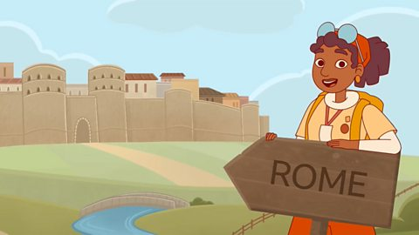
Maths:
- Counting, partitioning and calculating, including decimal notation and negative numbers.
- Securing number facts and understanding shapes,
- Handling data and measures-
- Calculating and understanding shapes and properties.
- Measuring angles.
- Working out fraction and converting to decimals.
- Memorising multiplication tables.
- Time

Literacy:
Language and sentence structure: We will be exploring different narrative styles (1st and 3rd person), exploring verb and adverb structures and how to correctly apply in terms of past, present and future tense. Children will be exploring instructional text, play scripts, fictional and historical contexts. We will be discussing use of language and style.
Writing: Children will be practicing the above explored themes and complimenting them with their writing, to include, writing traditional tales, imaginative and informational writing.
Grammar and Punctuation: Singular and plural nouns, pronouns, compound words, adverbs to express time and cause, possessive pronouns ,fronted adverbials, prepositions and the use of standard English.
Spellings: Spellings from the Spelling 1A and 1B. Spelling test will be held first thing every Friday morning. Please continue to encourage children to revise for their spellings test and make sentences using the spelling words.
Reading: Guided reading carried out during school hours to monitor on going progress. Focus for this term will be fiction books. Children are highly encouraged to continue reading at home every day.


PHSCE
Digital well-being
TEAMs

Science
- The Human Body and digestive system
- Animals and their habitats

Art/D.T
- British Art
- Exploring a selection British artists and their style of work.

Computing
- Online safety

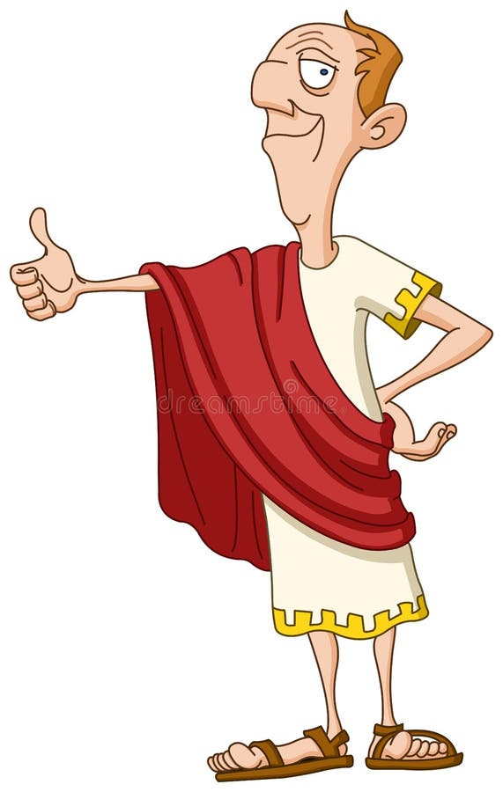
History/Geography
- Romans
Exploring the roman invasion of Britain and the impact on Britain
- Around the World
Exploring climate around the world and looking at the differences between the hemispheres.

