
English:
Language and sentence structure: We will be exploring different narrative styles, adjectives and adverbial structures and ending. How to use expanded nouns and fronted adverbials correctly within sentences. Children will be studying a range of text including fictional, newspaper reports and narrative poetry.
Writing: Children will be practicing the above explored themes and complimenting them with their writing, to include, writing a mythical fantasy piece, poetry and non-chronological writing.
Grammar and Punctuation: We will be discussing the use of commas , inverted commas and present tense verbs.
Spellings: Spellings from Twinkl 2A and 2B. Spelling test will be held first thing every Friday morning.
Reading: Scare at the Shadow Fair.
Guided reading carried out during school hours to monitor on going progress. Children are highly encouraged to continue reading at home every day.
Maths:
- Counting, partitioning and calculating, including decimal notation and negative numbers.
- Securing number facts and understanding shapes,
- Handling data and measures-
- Calculating and understanding shapes and properties.
- Measuring angles.
- Working out fraction and converting to decimals.
- Memorising multiplication tables.
- Time

Remember your PE kit every Thursday

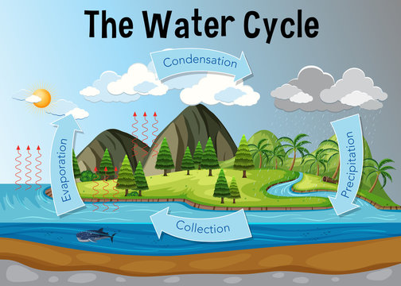
Computing
- Word Processing
Art/D.T
- Art: European Art

Science
- Electricity – creating circuits
- Scientist and Inventors

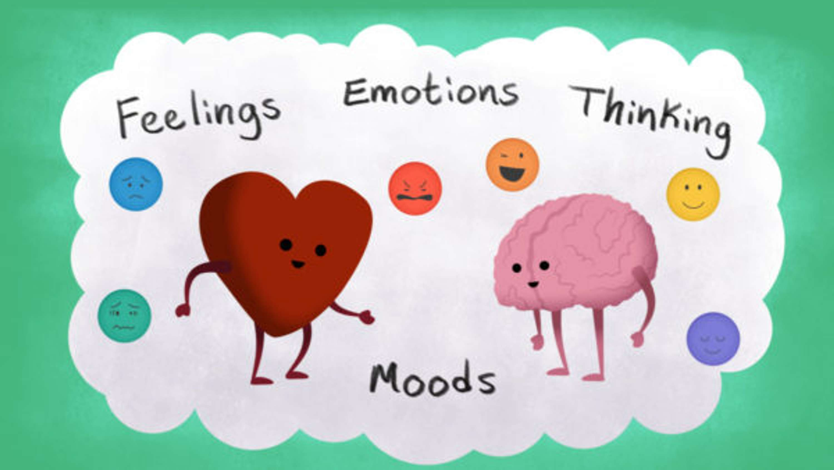
PHSCE/HRE
VIPs: Exploring our relationships with those around us
Think Positive: Mental health focused on learning and developing

History/Geography
- Vikings and Anglo Saxons – Exploring the Viking raid and invasion of Britain.
- Water – Exploring the formation of water and the water cycle

