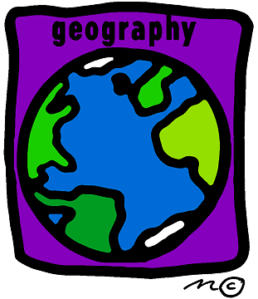

In Geography children learn about water supply around the world. They learn about the importance of clean water and investigate how it is supplied. They also consider who owns and manages water and contrast water use at home with use in less economically developed countries.

