Curriculum Overview – Autumn One Term 2025/2026

Year 6
Science:
Living things and their habitat:
Describe how living things are classified into broad groups according to common observable characteristics and based on similarities and differences, including microorganisms, plants and animals.

English: Fiction Fairytales, Fantasy and Beyond & Spy fiction.
- Comprehension (narrative fiction) and summarising text.
- Exploring genres
- Comparing genres and features
- Planning and writing fiction of my own.

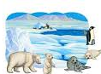
Maths:
This term year 6 will be focusing on:
- Number and place value
- Mental addition and subtraction
- Measurement
- Problem solving, reasoning and algebra
- Geometry: property of shapes
- Geometry: position and direction
- Measurement
- Position and Direction

PHSE: Digital wellbeing
In PHSE, the children will learn how to look after their wellbeing while being online. They will also learn about the potential risks online.
PE: Gymnastics
Pupils will develop fundamental movement skills, become increasingly competent and confident with their own motor skills. They should be able to engage in a range of competitive and cooperative physical activities, in a range of increasingly challenging situations.

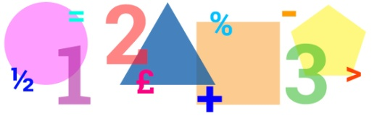

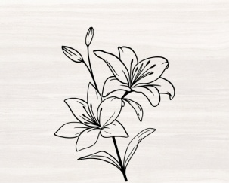
Art: Plants and Flowers
Children will be using a range of materials and techniques to create their own art pieces.
Geography: Raging Rivers
Children will learn about the water cycle, rivers and the effect they have on the landscape. They will look at how rain finds its way into rivers and how rivers develop from the source to entering the sea.

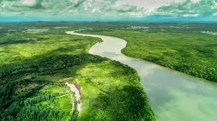
Computing: E-safety
Children will learn about how to stay safe online.

