Curriculum Coverage Overview – SpringTerm 2025/2026
Science:
Light:
Recognise that light appears to travel in straight lines. Use the idea that light travels in straight lines to explain that objects are seen because they give out or reflect light into the eye. Plan different types of scientific enquiries to answer questions, including recognising and controlling variables where necessary.

Year 6
ART: To consider the use of calligraphy in Islamic art. Calligraphy is the most highly regarded and most important element of Islamic art. The Qur’an is written in Arabic; so Arabic script was altered and beautified over many centuries in order that it might be worthy of “divine revelation”. Children in year 6 will. Understand how people can express themselves through art - the use of Calligraphy. Children Can describe what calligraphy is and be able to write their name with some artistic flair to it. Some can evaluate the importance of calligraphy to Muslims and critically evaluate the effectiveness of it.

English:
Plunge into your Spring Revision Term with our Greek Myth-Themed Y6 Revision Block.
Revise all necessary grammar, punctuation and spelling for the Y6 SPaG tests, as well as reading, comprehension and writing activities within an inspirational term's work that follows the sequence of selected Greek Myths & Percy Jackson and the Lightning Thief.
This Y6 English revision block is designed to provide a truly inspirational term's work. It is divided into nine units that guarantee an exciting and stimulating literary experience, as well as covering all necessary revision, including the grammar, punctuation and spelling for the SPAG tests as well as reading, comprehension and writing.

English:

Plans and Plan Resources For each unit there is:

• focused grammar revision
• formal SATs-style comprehension activities
• reading and writing focuses linked to a genre
• stunningly illustrated resources, including grammar PowerPoints and posters
• quick-fire 5-minute revision PowerPoints using SATs format and wording.

The 5-minute revision PowerPoints deliver quick, focused revision activities, for grammar and punctuation and require children only to have whiteboards. They are designed to need no preparation and to be used in those precious spare minutes. They are intentionally similar in content and style to the formal KS2 tests

PHSE:This term children in year 6 examine ways in which conflict can be caused by words, gestures, symbols or actions;understanding the need for rules and that they are necessary for harmony at home and at school; anti-social behaviour (for example bullying and racism); and - appreciating how and why rules and laws are created and implemented.

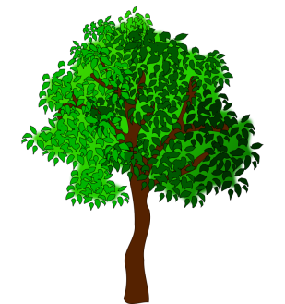
Geography:discover some of the many ways in which the world around them is changing, from coastal erosion to political changes. Pupils will learn about the structure of the United Kingdom and how its shape and geography have changed over thousands of years. In the final lesson of this unit, children have the chance to predict the future and look at which might change again in their lifetime.
PE:PE DAY: Tuesday
Pupils will develop fundamental movement skills, become increasingly competent and confident with their own motor skills. They should be able to engage in a range of competitive and cooperative physical activities, in a range of increasingly challenging situations.

Maths:
This term year 6 will be focusing on SATs Revision.

Spring Term: 45 days teaching across six short blocks. Many units in these blocks are accompanied by new SATs-style questions:

Y6 SATs Practice
Spring and Summer Term: Two complete Revision Menus will be covered to prepare children for SATs.

